*West Wind Angus Ranch \* 2022 Private Treaty Angus Bulls \* Stacey Gravenhof 507-360-7969*

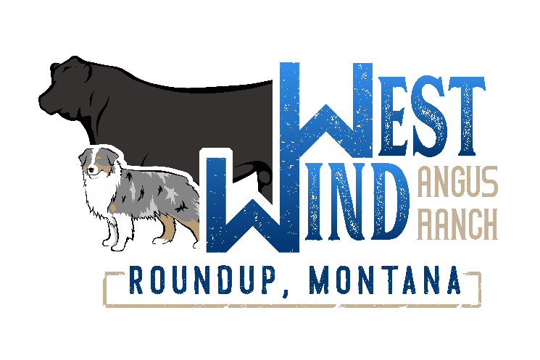

\*All Parentage Tested

*Great set of Bulls with lots of Calving Ease options!*

*Don’t hesitate to call my cell 507-360-7969*